**CN Lab Experiment 3**

**Part-1**

**Objective:**

In this experiment, you will configure a router and two PCs using Cisco Packet Tracer. The computers are connected to the router using copper straight-through cables. After setting up the network, you will test the connectivity by sending a simple PDU from PC0 to PC1. The successful simulation will demonstrate the router's capability to handle data transfers between multiple devices.

**Requirements:**

* Cisco Packet Tracer software.
* A GitHub account and a repository for lab assignments.
* Access to Google Classroom for submission.

**Procedure:**

**Step 1: Configuring Router**

1. Select the router and open CLI.

2. Press ENTER to start configuring Router1.

3. Activate privileged mode:

○ Type enable

4. Access the configuration menu:

○ Type config t (configure terminal)

5. Configure interfaces of Router1:

○ FastEthernet0/0:

■ Type interface FastEthernet0/0

■ Configure with the IP address 192.168.10.1 and Subnet mask 255.255.255.0 ○ ○ ○ ○ FastEthernet0/1:

■ Type interface FastEthernet0/1

■ Configure with the IP address 192.168.20.1 and Subnet mask 255.255.255.0

6. Finish configuration:

○ Type no shutdown to activate the interfaces

**Step 2: Configuring PCs**

1.Assign IP addresses to each PC:

○ PC0:

■ Go to the desktop, select IP Configuration, and assign the following:

■ IP address: 192.168.0.2

■ Subnet Mask: 255.255.255.192

■ Default Gateway: 192.168.0.1

○ PC1:

■ Go to the desktop, select IP Configuration, and assign the following:

■ IP address: 192.168.0.66

■ Subnet Mask: 255.255.255.224

■ Default Gateway: 192.168.0.65

**Step 3: Connecting PCs with Router**

1. Connect the devices using copper straight-through cables:

○ Connect FastEthernet0 port of PC0 to FastEthernet0/0 port of Router1

○ Connect FastEthernet0 port of PC1 to FastEthernet0/1 port of Router1

**Results:**

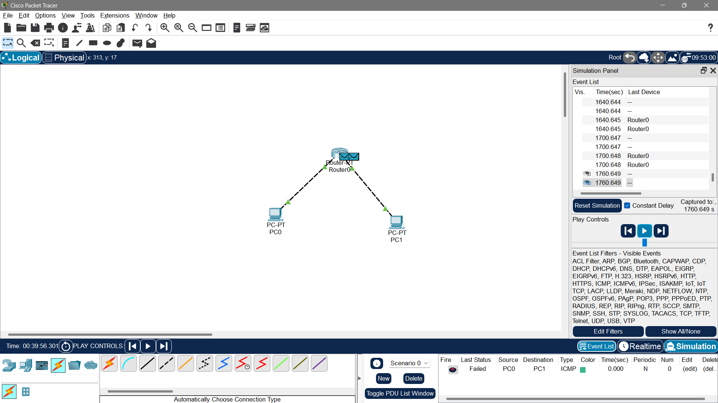

* We observe the packet traveling from PC0 to the router and then to PC1.
* The acknowledgment packet travels back from PC1 to PC0, confirming successful communication.

**Part-2**

**Aim:**

The aim of this lab is to test your ability to perform a basic router setup. You have 15 minutes to complete this simulation.

**Procedures:**

1. Configure the LAPTOP terminal software with the right console parameters.

2. Configure the router hostname to "GATEWAY"

3. Configure the enable password and secret to "cisco"

4. Configure password encryption on the router to secure stored passwords

5. Configure the console access:

- Login: yes - Password: "cisco"

- History: 10 commands

- Logging synchronous

- Timeout: 2 minutes 45 seconds.

**Solution**:

1.Configure the laptop terminal software The terminal software in not correctly configured on the laptop. You have to change the settings to 9600 / 8 / None / 1 to connect to the router's console.

2.Configure the router's name The hostname command has to be used to changethe router's hostname..

3. Configure the enable password and secret to "cisco" The enable secret command stores a MD5 hash of the password required for privileged mode access. The enable secret password of a Cisco ISR router is used for restricting access to enable mode and to the global configuration mode (configure terminal) of a router.

4. Configure password encryption for this router GATEWAY(config)#service password-encryption 5. Configure the console access Console access is protected by the 'cisco' password and login is required at console access. The exec-timeout command automatically logs off user from console after defined inactivity period (2'45'' in this lab).

